How to apply to the Hutton Program
- Register your account at afsawards.awardsplatform.com
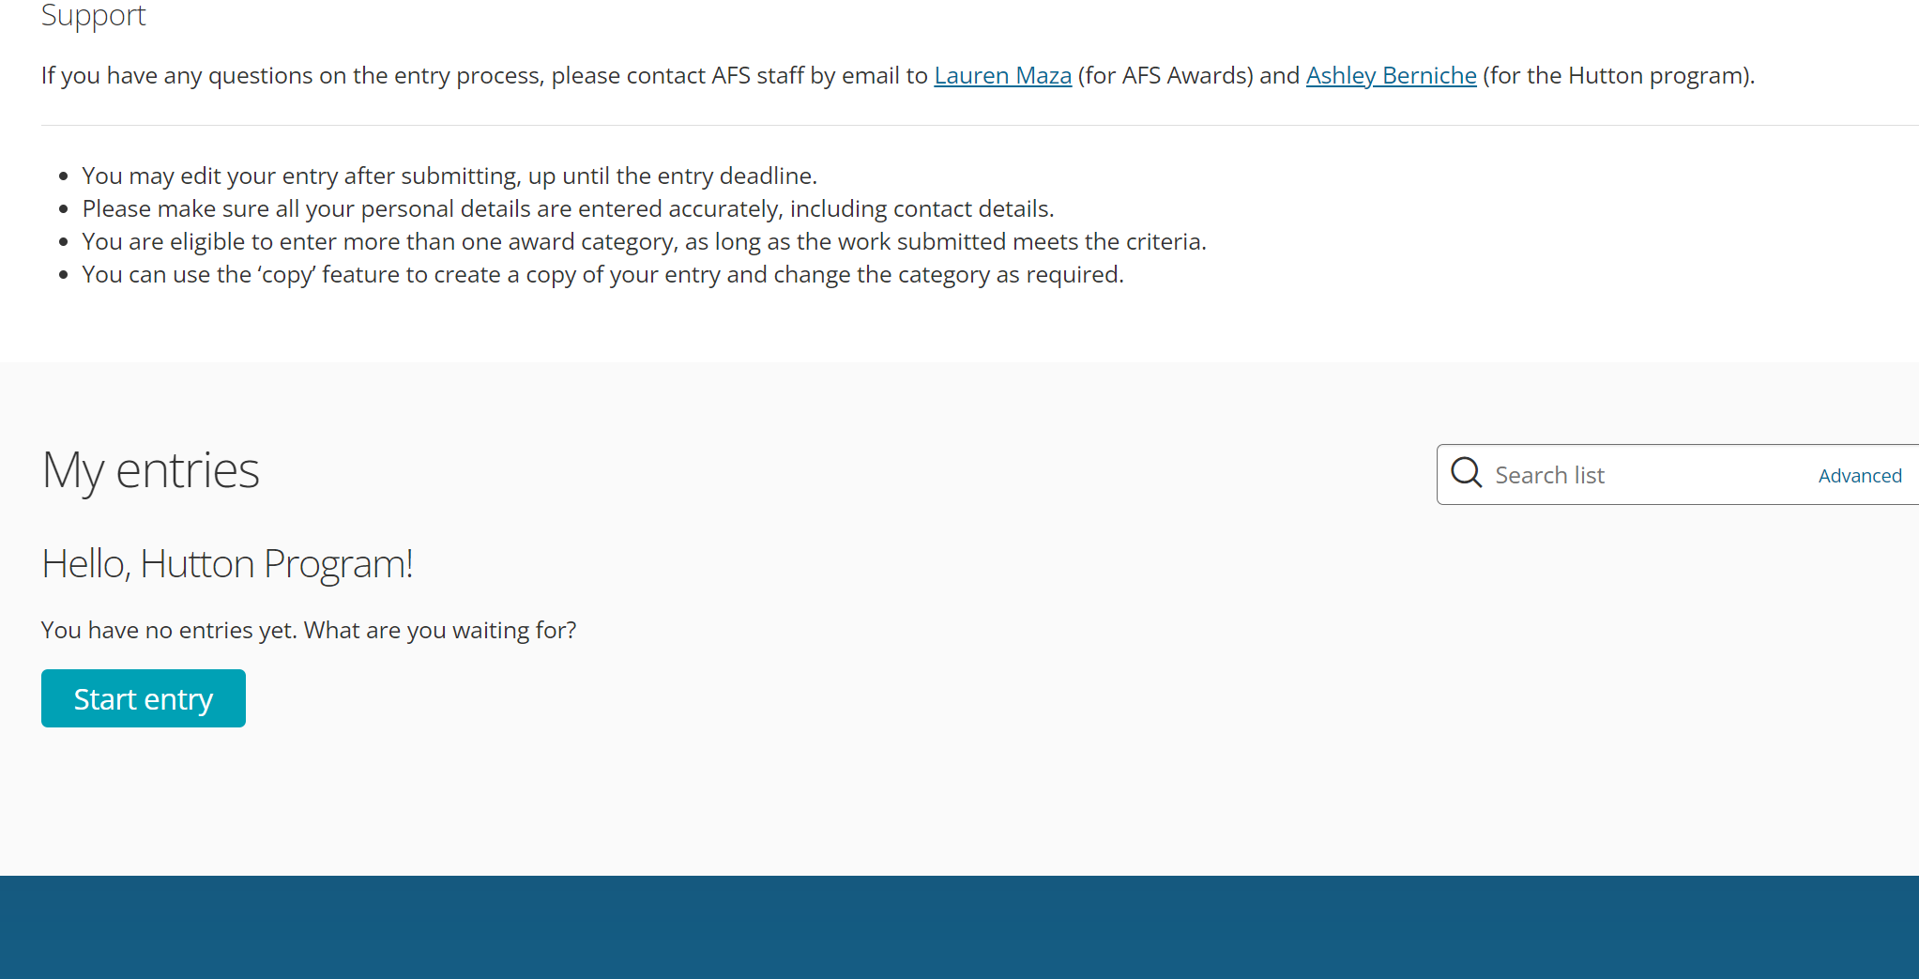
- Check your email to confirm your account
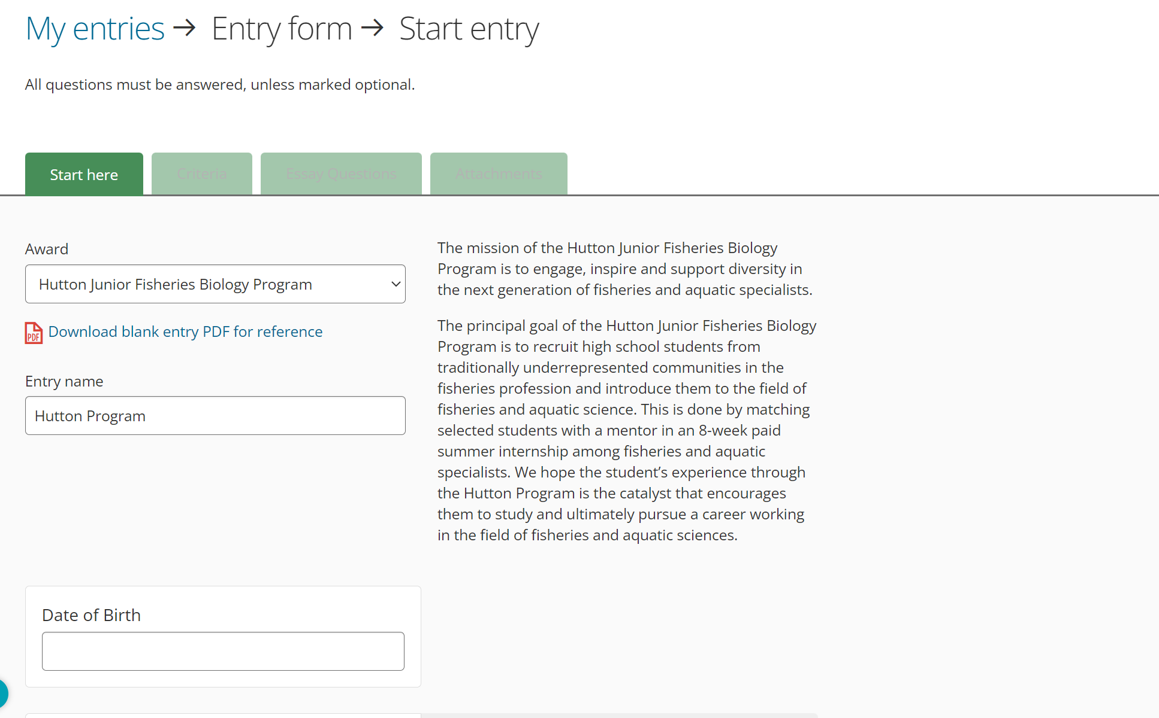
- Click “Start Entry, as shown above
- Under the “Award” drop down menu, select “Hutton Junior Fisheries Biology Program”
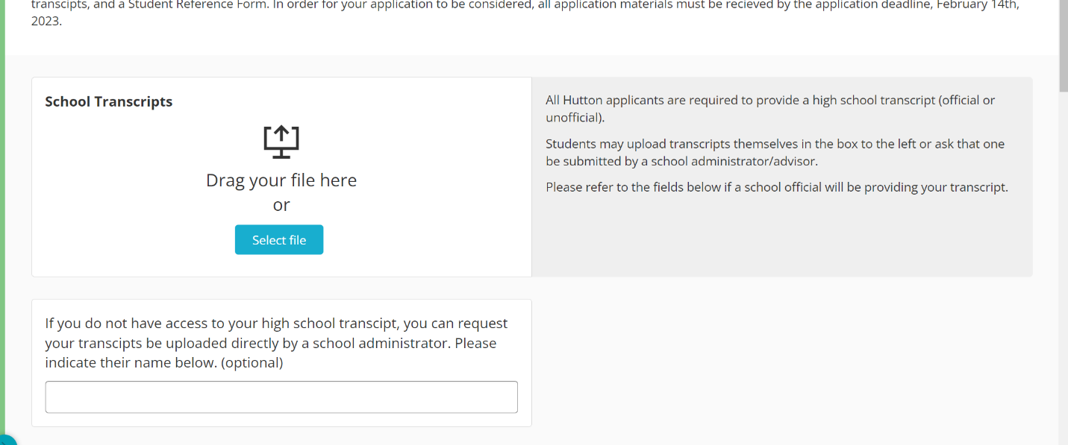
- All categories are required unless stated “optional.” Please fill out the application completely and accurately. You can save your application and come back later to work on it.
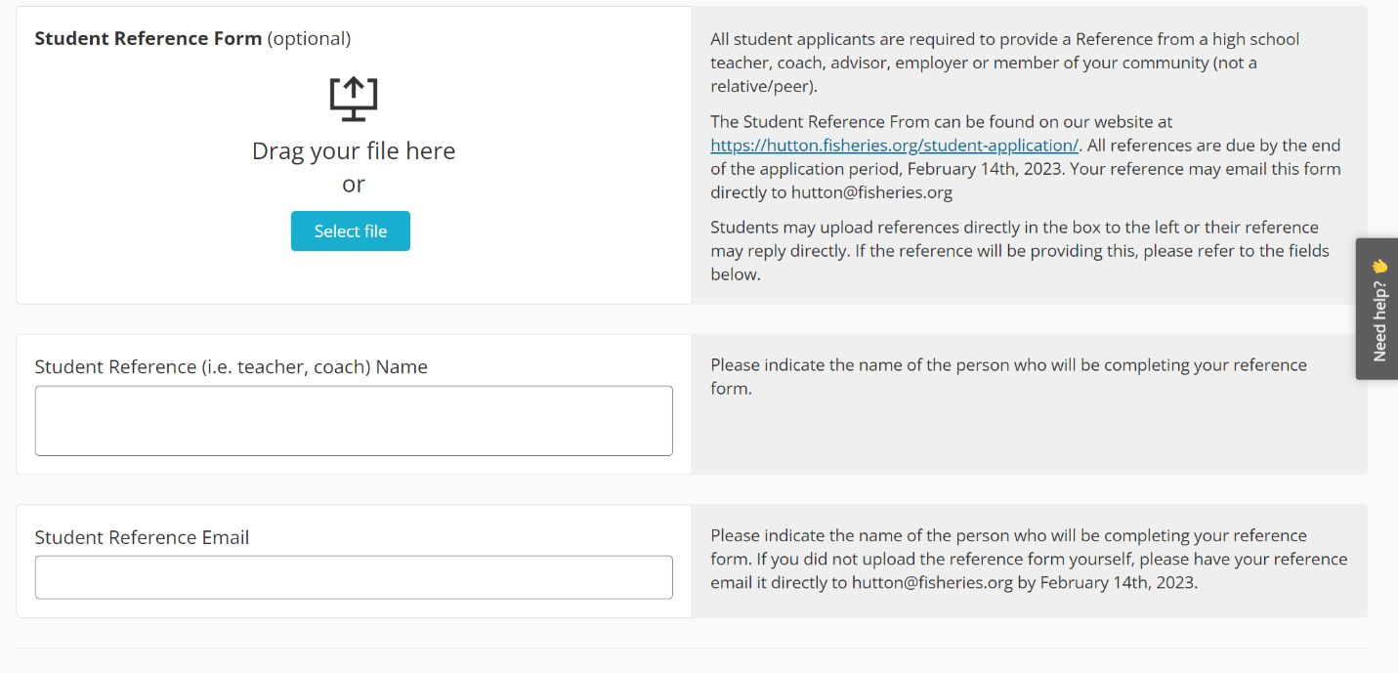
- Under the “Attachments” tab, there will be a section to upload your transcript. You can upload unofficial or official transcripts in PDF format. If you are unable to access your transcript, you can enter a school administrator’s email address. They will receive an email where they can directly upload your transcript to the application.
- Student reference forms can be uploaded directly by the student or emailed to hutton@fisheries.org by the person referring you. Reference forms MUST be received by February 14th, 2023.

If you have any questions about completing the application, please email hutton@fisheries.org

