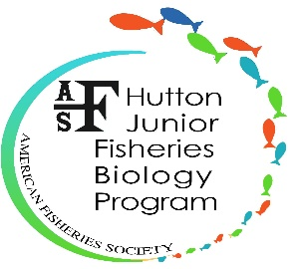
Hutton Junior Fisheries Biology Program
American Fisheries Society
425 Barlow Place, Suite 110, Bethesda, MD 20814-2199, USA
Phone: (301) 897-8616
www.hutton.fisheries.org

OVERNIGHT TRIP AGREEMENT FORM
The American Fisheries Society (AFS), Hutton Junior Fisheries Biology Program hereby enters into this Overnight Trip Agreement with (Mentor’s Institution) ____________________________________, for the volunteer services of (Scholar’s Full Name) ____________________________________, hereinafter referred to as the parties, in the form of a paid student internship at AFS. This agreed-upon Student over-night assignment is made on a voluntary basis, and all parties will be obligated to uphold all rules and responsibilities in accordance with the provisions set forth herein.
- Purpose

By agreement and for mutual benefit of the parties, (INSERT SCHOLAR NAME) will serve in a student volunteer capacity at the Mentor’s site for an overnight trip in accordance with the American Fisheries Society’s Hutton Junior Fisheries Biology Program rules, regulations, and policies.

- Duration, Extension, and Termination of Assignment

- This student overnight trip assignment will commence on _________ and end on ________. Request for an extension must be submitted to the AFS Educational Program Coordinator in writing prior to the initial assignment ending.

- This overnight assignment may be terminated prior to the initial end date by either party or the mutual consent of both parties; however, there must be at least a 3-day notice in writing by either party of intent to terminate the assignment.

IV. Rules, Regulations, and Policies
  - Students must adhere to the agreed-upon reporting schedule, and notify the assigned Mentor at least 7 days in advance of any need to change the schedule or need to be absent.
  - The Hutton Program provides liability insurance for coverage for each Hutton Scholar.
  - The Hutton Program requires the following from all Hutton Scholars:
    - Do not use alcohol, tobacco or drugs.
    - Do not have firearms or weapons that aren't an institutional requirement for the task.
    - Never use abusive language.
    - Always wear seat belts.
    - Ensure your Mentor provides all the necessary protective items.
  - If a student is detained by law enforcement for any reason, that student’s trip will be immediately terminated and the parents contacted. Parents will be responsible for their child in such situations.
  - Notify the AFS Educational Program Coordinator of any health concerns or on-site injury in order to be eligible for AFS Hutton Program’s liability insurance.
  - Assume responsibility for one’s personal and professional actions and conduct.
  - Complete mandatory AFS overnight evaluation form at the end of the visit.

V. Approvals
It is understood that this agreement will be in effect until the assigned completion date of this Student Volunteer Services Agreement, unless it is terminated prior to the completion date, as stipulated above. This agreement shall be construed and enforced in accordance with all applicable AFS regulations and policies.
- Student Emergency Contact Information
Emergency Contact Name & Relationship: ______________________________________________________________
Address: __________________________________________________________________________________________
Phone: (______) __________________ Email: __________________________________________________________
- Student Signature of Agreement:
I have read the above and agree to perform volunteer services under the conditions described in this agreement. It is understood that I will be considered a student volunteer intern, known as a Hutton Scholar, for the duration of the overnight trip in accordance with the American Fisheries Society’s Hutton Junior Fisheries Biology Program rules, regulation and policies. I am not entitled to any compensation for overtime work and my trip will be immediately terminated if I do not abide to the rules, regulations, and policies set forth. I have discussed my duties, responsibilities, and summer schedule with my Mentor and Parent.
_______________________________________________
(Last) (First) (Middle)

_______________________________________________ ______________________
Student’s Signature Date

- Parental Permission Statement
I have read the above overnight trip rules, regulations, and policies under the conditions described in this agreement. It is understood that if my child is detained by law enforcement for any reason and if the student violates the agreement set forth, that student’s trip will be immediately terminated. I hereby waive and release any claim against American Fisheries Society Hutton Junior Fisheries Biology Program if my child violates any stipulations in this agreement.
I hereby grant permission for my child, __________________________________, to participate in an
Student’s Name
overnight trip from _____________________ to _______________________ with his/her mentor,
Month, Day, Year Month, Day, Year
______________________________________.
Mentor’s First and Last Name
________________________________________________________
Please Print Parent’s (or Guardian’s) Name

_________________________________________________________ _____________________________ Parent’s (or Guardian’s) Signature Date
- Mentor Approval Statement
I have discussed with my Hutton Scholar the required duties, responsibilities, and summer schedule, including start and end dates of participation for the overnight trip. I hereby agree to serve as a Hutton Program Mentor for the following student: ____________________________________. Subsequently, I will complete and submit this Overnight Form Agreement to the AFS, Educational Program Coordinator.

___________________________________________________________
Please Print Mentor’s Name

____________________________________________________________ __________________________________
Mentor’s Signature Date
- American Fisheries Society Signature of Agreement:
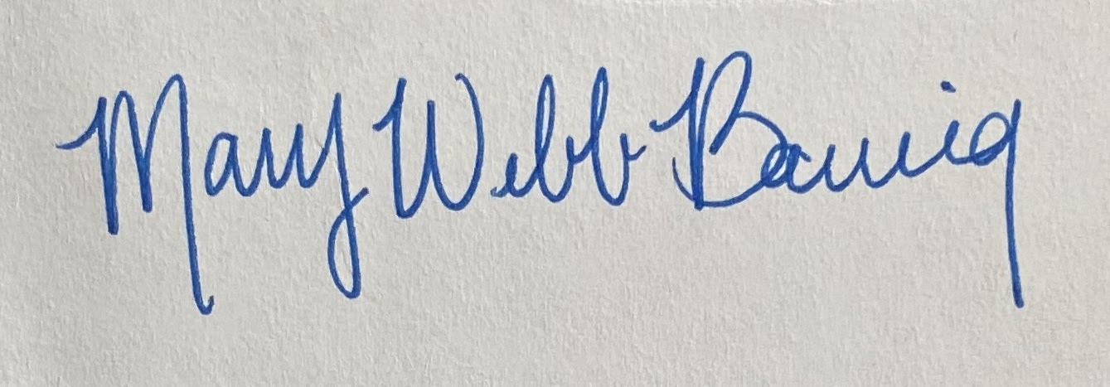

_______________________________________ Date ______________
Mary Webb Banning
Educational Program Coordinator
(301) 897-8616 ext. 204; mbanning@fisheries.org

