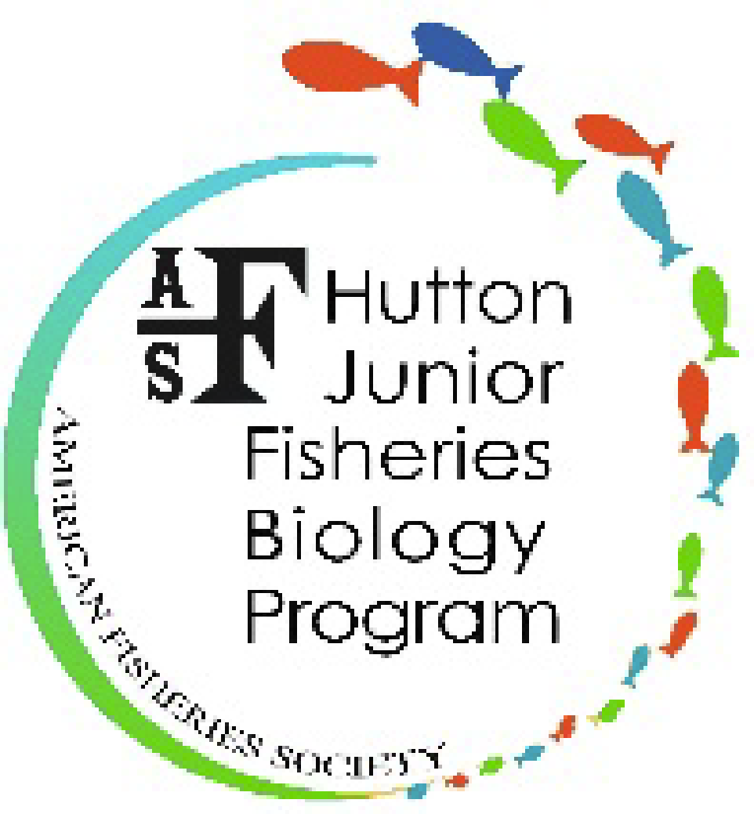
American Fisheries Society
Hutton Junior Fisheries Biology Program
425 Barlow Place, Suite 110
Bethesda, MD 20814-2199
(301)897-8616
hutton@fisheries.org • http://hutton.fisheries.org/
_____________________________________________________________________________________
THE HUTTON JUNIOR FISHERIES BIOLOGY PROGRAM CHARACTER RECOMMENDATION
From a supervisor, community/organizational leader, teacher or other adult (not a relative/peer)
The principal goal of the Hutton Junior Fisheries Biology Program is to stimulate interest in pursuing careers in fisheries science and aquatic resource management among high school students from groups underrepresented in the fisheries professions. The application is open to all high school students in the class of 2021, 2022 and 2023 regardless of race, creed, or gender. Because the principal goal of the program is to increase diversity within the fisheries professions, minorities and females are strongly encouraged to apply.
Students selected for the program are matched with a fisheries professional for a summer-long, exciting and hands-on fisheries experience in a freshwater and/or marine setting. Each selected student must complete a mid-summer and final report in order to fully complete their internship and receive the entire internship payment amount.
In your recommendation, please describe in what capacity and for how long you have known the student. Please provide an analysis of the student’s character and strengths in a social setting and/or work environment as well as any additional information you consider relevant. Please type your recommendation on your organization’s letterhead and include all of the information listed below.
To submit the letter of recommendation, please email the Word or PDF file to hutton@fisheries.org with your signature for consent by February 15th, 2021.
Please include in your recommendation all of the information listed below.
- Student’s name
- Recommender's name
- Relation to Student
- Recommender's email
- Name of high school

